**F**ood**E**x Online Food Delivery Application

### BUSINESS APPLICATION

**Description:**

* FoodEx is an online and mobile food ordering and delivery company; bridging neighbouring restaurants to the urban diners via delivery executives.
* We aggregate the restaurants and have our own fleet of delivery executives, who pick up the orders from the partner restaurants and deliver it to the customers at their doorsteps.

**Process:**

* Once the customer has selected the restaurant and order is placed, the restaurant that has its own interface receives the order details and starts preparing for the order.
* A broadcast signal is then sent to all the drivers in the vicinity who have their own driver application. Those willing to accept the order can choose to accept and deliver it.
* We also have real-time updates for the customer to track their order status.

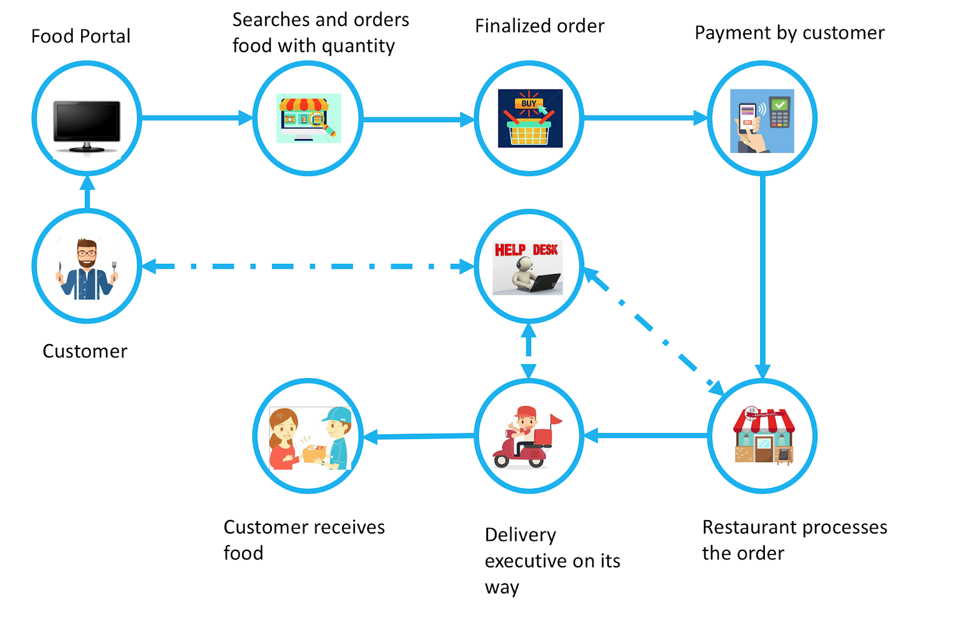

### APPLICATION USERS

**Customer:** Customer represents anybody who uses our online food delivery service.

**Restaurant:** Restaurants are the partners tied up with FoodEx, primarily responsible for preparing food.

**Delivery executive:** Responsible for picking up food from the restaurant and delivering it to the customers.

**Support:** They help to resolve issues faced by all the stakeholders.

### STAKEHOLDERS TASKS AND GOALS

|  |  |  |
| --- | --- | --- |
|  | **Task** | **Goal** |
| **Customer** | * Open App or visit website * Login, continue as Guest or create account. * Setup location * Browse restaurant listings and their menu * Add food items to cart * Review order and proceed to checkout * Choose default address or add new delivery address * Choose default payment method or use different payment method * Confirm payment and wait for the order to arrive * Track order * Accept order delivery. Pay cash if the payment method was Cash on Delivery (COD) * Rate the delivery executive / restaurant (optional) | * Find and order desired food items in the shortest time possible |
| **Restaurant** | * Accept or Reject customer order and update app * Prepare order * Handover food to the Delivery executive * Update the application at key stages | * Reject least possible customer orders * Prepare the best quality food in the least possible time period |
| **Delivery executive** | * Accept order pickup * Pickup order from restaurant * Deliver food to the customer * Receive payment in cash if required * Provide customer feedback * Update the application at key stages | * Deliver food items in the shortest time possible |
| **Support** | * Help customer, restaurant and delivery executive resolve issues | * Ensure each user type gets the support they need for a smooth overall experience |

### PROCESS DIAGRAM

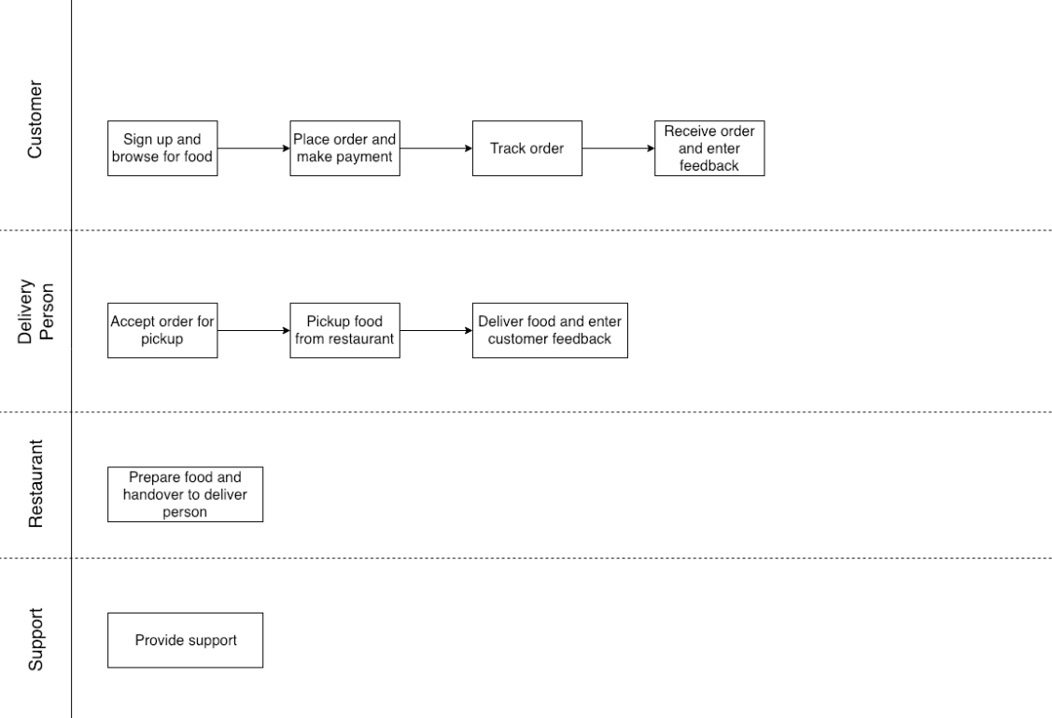

* At a high level, we identified 4 main actors of our business application viz Customer, Delivery Person, Restaurant and Support.
* A customer’s role is to sign up and browse for food, place order and make payment, track order and receive order and provide feedback.
* A Delivery person’s role is to accept the order for pick up from restaurant and deliver food to the end customer.
* A Restaurant’s role is to check inventory, accept/reject order, prepare order and handover the order to the delivery person.

### SWIMLANE DIAGRAM

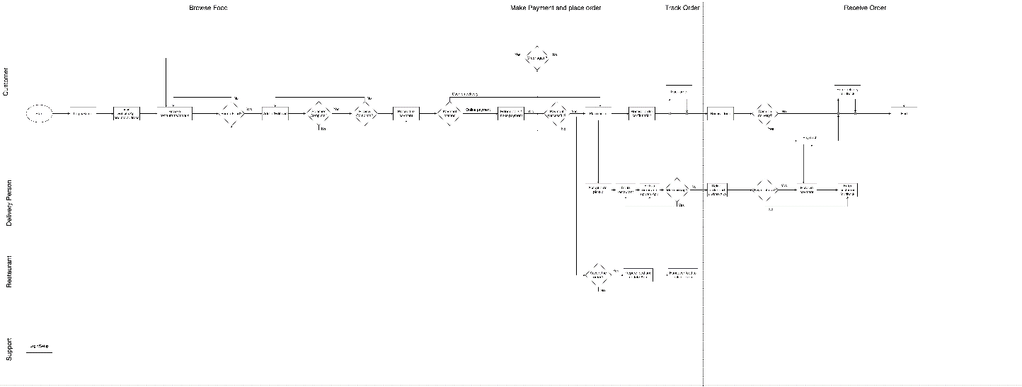

Diagram attached separately.

* The above process diagram helped us to further design in-depth process flow of each of our actors.

### ER DIAGRAM

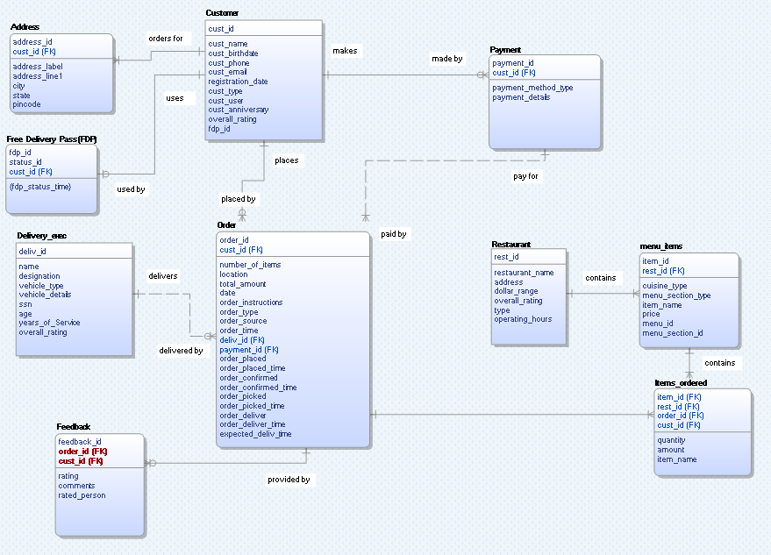

Diagram attached separately.

* After designing our business application conceptually, we designed a graphical representation of our model and created different entities and identified their relationships among them.

### PHYSICAL MODEL

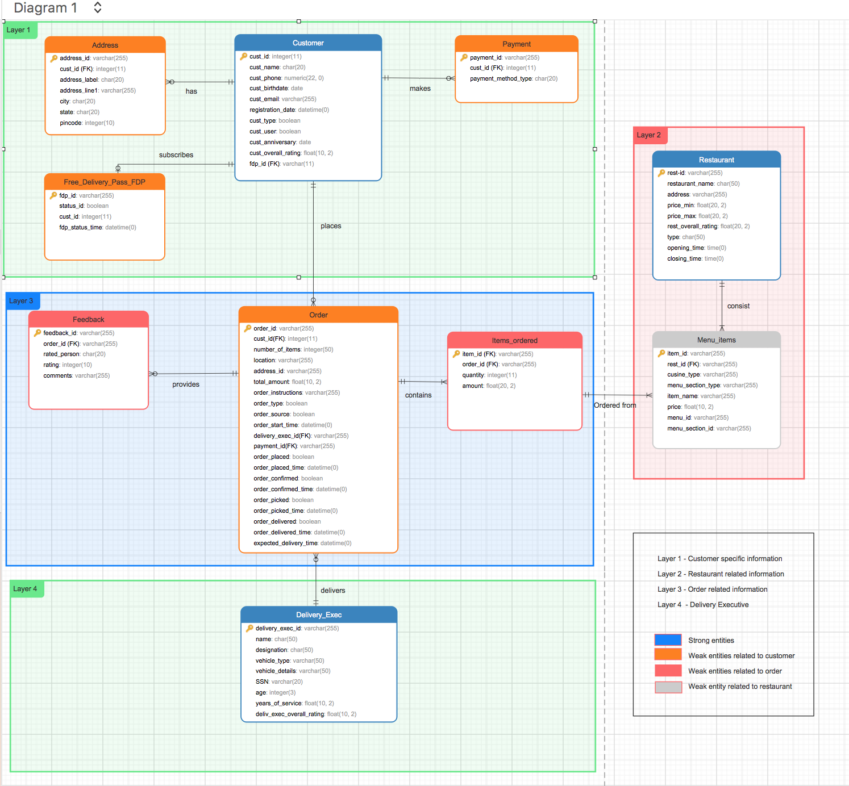

### USE CASE 1: ANALYSIS OF CUSTOMERS

1. **To identify the new customers per month based on customer type that signed up on the platform (Customer Acquisition)**

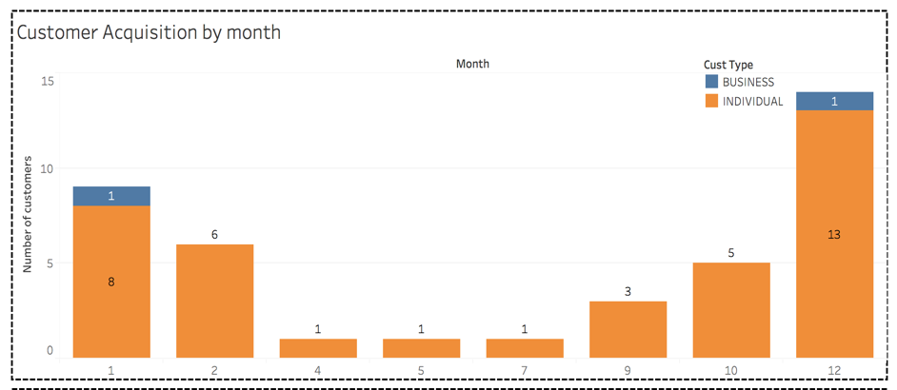

The above graph represents the number of new customers that signed up per month and the distribution of these customers based on customer type i.e. Individual v/s Business.

This was achieved by extracting month from the registration date column and grouping the customers by month.

1. **To Identify customer churn rate**

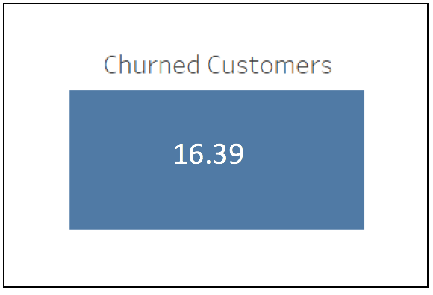

* The above tile indicates the churned customer rate. The churned customers are those who didn’t place an order since the last two years.
* This was achieved by creating a procedure to identify these customers. The conditions are as follows:
  + If the order placed time is NULL and the registration date is more than 2 years ago.
  + If the order placed time is NOT NULL then if the last order is placed more than 2 years ago.
* The rate was calculated by dividing the total of these customers to the total number of customers.

1. **To calculate 'Free Delivery Pass’ renewal rate per month**

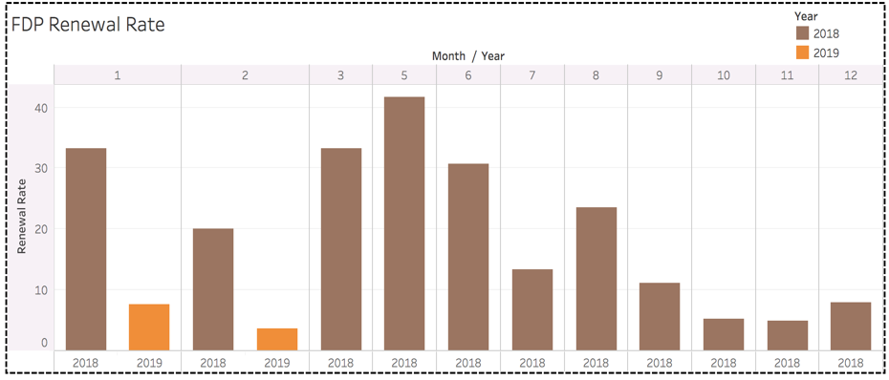

* The above graph shows the FDP renewal rate based on month and year
* This was achieved by creating an update trigger on FDP master table, which activates whenever the status of FDP changes from 0 to 1, 1 to 1 i.e. renewal and inserts the old value into the log table
* Based on Master table and the log table, the renewal rate was calculated grouping by month.

1. **To identify the inactive customers:**

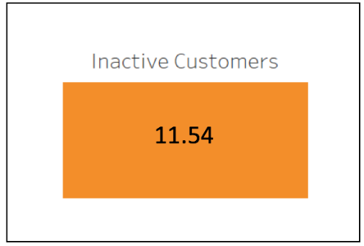

* The above tile provides the inactive customer rate. The inactive customers are those who have registered but never placed an order.
* This was achieved by using a dual method to divide the output from two select queries.
* The numerator query calculated the number of bounced customers by checking if the customer id is present in the order table using a subquery.
* The denominator was the total number of customers.

### USE CASE 2: ANALYSIS OF ORDERS

1. **Which cuisines is/are ordered most frequently?**

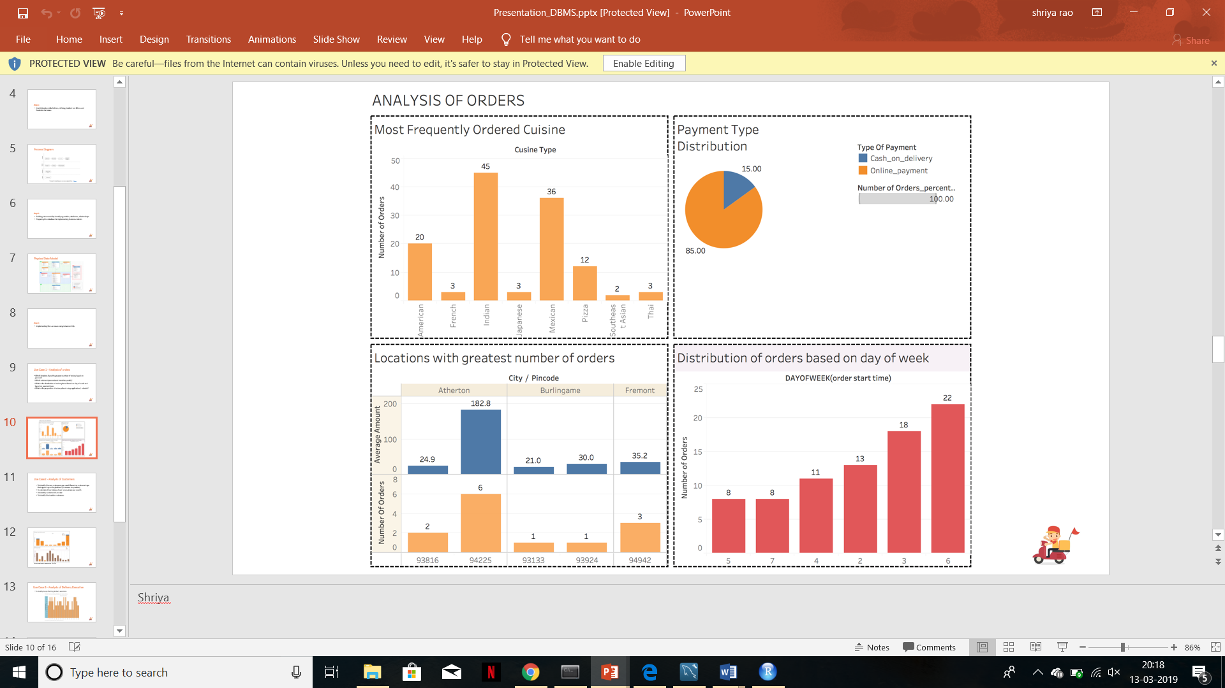

* We see that Indian and Mexican are the two popular cuisines. This was achieved using inner joins between the master table menu_item containing the items and cuisine and the items_ordered table which has the list of items ordered for every order

1. **What is the proportion of customers using online payment versus cash on delivery?**



* Customers have the option of saving multiple payment types, be it debit or credit card. Hence the option he/she selected is captured against that particular order. This was achieved using a case statement for online and cash on delivery.

1. **Which locations have the greatest number of orders based on pincode?**



* Atherton with pincode of 94225 has average amount of 183$ and highest numbers of orders as well.
* To achieve this an inner join between the order table and address table was used and used a 2 group by variables, city and pincode.

1. **What is the distribution of orders placed based on day of week and based on payment** type?



* Day 6(which is a Saturday) received most orders with total 22 orders. Our dataset contains the timestamp recorded against each order placed and DAYOFWEEK function was utilized to obtain the day and then counted the total number of orders for each day of the week.

### USE CASE 3: ANALYSIS OF DELIVERY EXECUTIVE

1. **To identify top performing delivery executives**

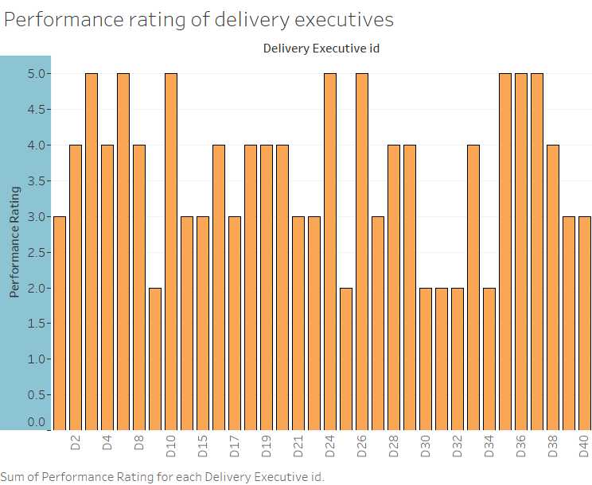

* The above graph represents the performance ratings computed by FoodEx for all the delivery executives
* The rating is computed based on the average delay in the orders delivered by the executives

### LEARNINGS

* Scoping
* Detailed processes and Swim lane diagram
* Data modelling
* Visualization
* Use of SQL to implement business metrics

### CHALLENGES

* Entity relationship constraints
* Exploring SQL syntaxes
* Debugging

If we were to do this project differently, we would have done the following things:

* Choose alternate database like MONGODB.
* Data loading to be done at an earlier stage to understand the relationship among the various entities.